PAYOUT LENS
See where your
TikTok Shop payout went.
A plain-English screenshot guide for the standalone, local settlement explainer.
ONE HTML FILE | NO PLUGINS | NO LOGIN | NO UPLOAD

Fastest way to learn it
Open the HTML file and click Load a fictional payout demo. The complete reveal appears in seconds without using real shop data.

USER GUIDE / RELEASE 0.1.0 / AUGUST 1, 2026
START HERE

Use the right file
Payout Lens turns a TikTok Shop settlement workbook into a trail from gross sales to settlement to recorded payout. It highlights deductions, adjustments, reserves, and rows worth checking in Seller Center.
- Use a TikTok Shop settlement report in .xlsx format.
- The workbook must contain an Order details tab.
- Maximum file size is 25 MB.
- CSV, PDF, legacy .xls, Orders reports, and Sales reports are not accepted.
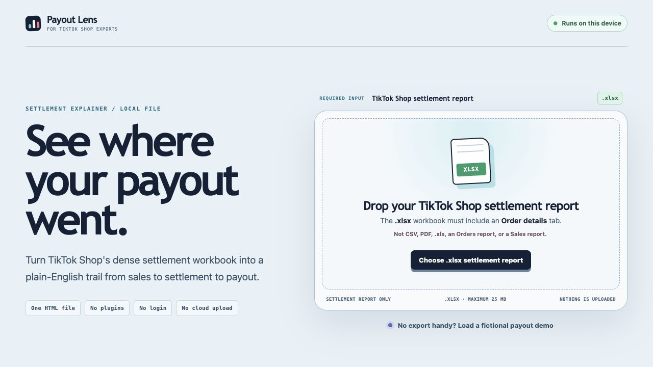
The opening screen names the exact input beside the file chooser. No plugin, login, or cloud upload is required.
CSV is output only
Payout Lens can create clean CSV summaries after analysis, but the input must be the TikTok Shop settlement workbook in .xlsx format.

FICTIONAL DEMO

Learn the screen before using real data
1. | Open Payout-Lens.html in a modern browser.
2. | Click Load a fictional payout demo.
3. | Look for the FICTIONAL DEMO label at the top of the result.
4. | Follow the payout trail, deductions, adjustment labels, and Review Queue.
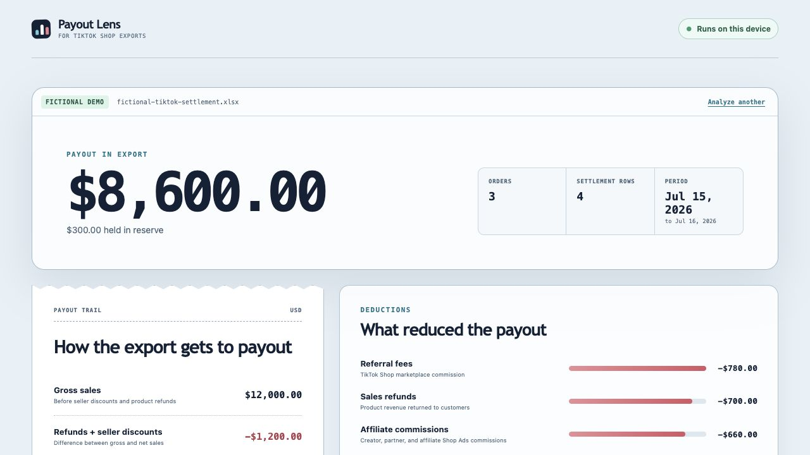
The fictional reveal shows the recorded payout, reserve, order count, period, payout trail, and largest deductions.
Safe for public demos
Use the fictional demo for screenshots and videos. Do not record real seller IDs, payment IDs, order IDs, bank details, or customer data.

REAL WORKBOOK

Analyze your settlement report
1. | In TikTok Shop Seller Center, open Finances > Statements or Payouts > Export.
2. | Choose a date range and download the settlement report.
3. | Open the .xlsx workbook once and confirm it contains an Order details tab.
4. | Drag the workbook onto Payout Lens, or click Choose .xlsx settlement report.
5. | The workbook is read locally and the result appears automatically.
Nothing is uploaded
Payout Lens has no server, account, analytics, or upload step. The workbook is processed inside the browser on the device where it was opened.

What appears at the top
RESULT | MEANING
Payout in export | Amount recorded in the workbook's payment table.
Orders | Distinct order IDs after adjustment-only rows are excluded.
Settlement rows | Order and adjustment rows used in the analysis.
Period | Dates covered by the analyzed rows.
Current TikTok US export reference: seller-us.tiktok.com/university/essay?knowledge_id=2336057241700098

READ THE RESULT

Follow the money in order
LINE | WHAT IT MEANS
Gross sales | Product revenue before seller discounts and refunds.
Refunds + seller discounts | Difference between gross and net sales.
Net sales | Revenue after those reductions.
Shipping | Signed shipping charges and reimbursements from the export.
Fees | Marketplace, referral, affiliate, refund, and transaction fees.
Adjustments | Exported reimbursements or deductions.
Settlement | Net sales + shipping + fees + adjustments.
Reserve | Money held back or released.
Payout | Amount recorded in the payment table.
How to read the signs
Negative values reduced the total. Positive values added to it. Exported math ties means the workbook arithmetic matches within two cents; it does not prove every fee was charged correctly.

DEDUCTIONS AND ADJUSTMENTS

See what reduced the payout
The deductions panel groups the largest negative amounts so the biggest drivers are obvious. The adjustment panel preserves the reasons written in the workbook rather than guessing what TikTok intended.
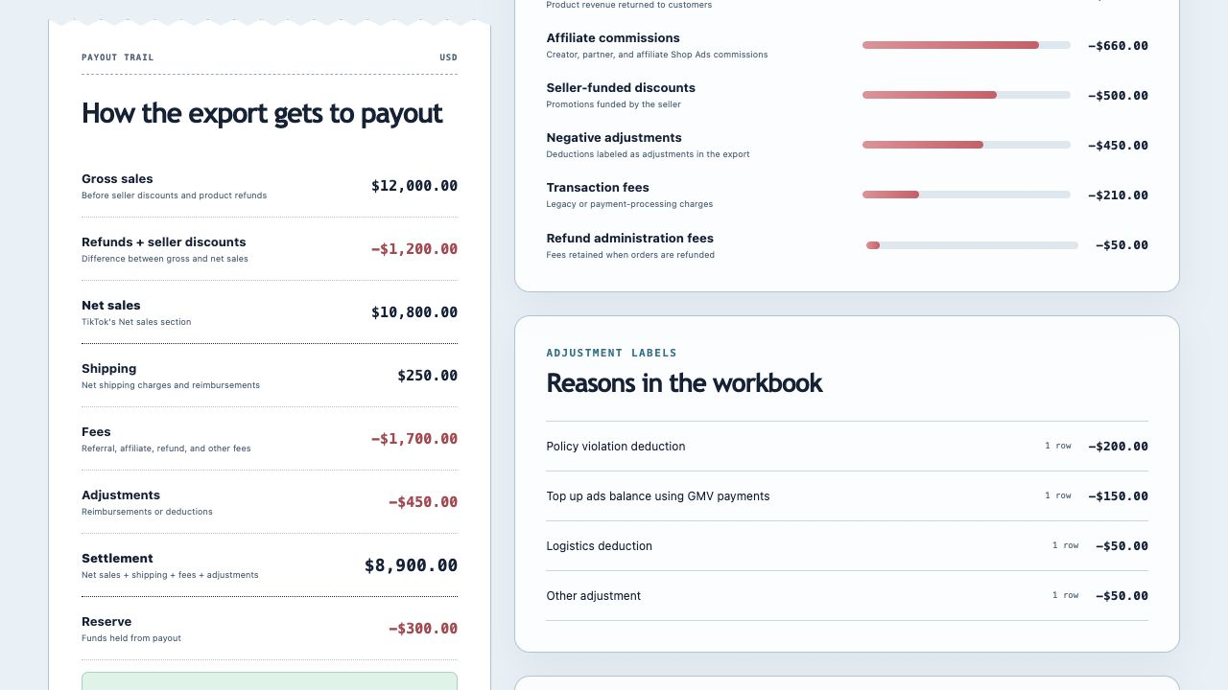
The payout trail sits beside the largest deductions and adjustment reasons from the workbook.
Important boundary
Payout Lens explains what the export says. It does not verify TikTok's fee policy or prove that a charge is incorrect.

REVIEW AND EXPORT

Know exactly what to check next
The Review Queue flags rows worth opening in Seller Center, including negative adjustments, missing reasons, row-math differences, payment-status problems, and gaps between statement and order-detail totals.
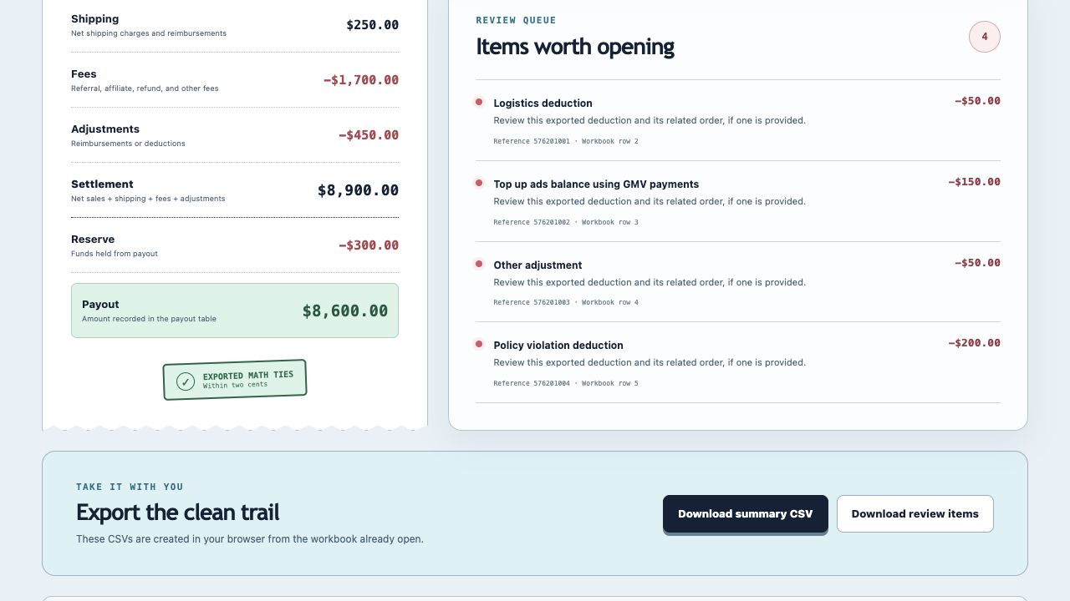
Use the reference and workbook row to investigate, then download a clean summary or review-items CSV.
- Download summary CSV creates a clean payout-trail summary.
- Download review items creates a separate list of flagged rows.
- The review-items button is disabled when nothing was flagged.
- Both files are created locally from the workbook already open in the browser.

TROUBLESHOOTING

Common problems and the fix
WHAT YOU SEE | WHAT TO DO
Settlement table not found | Export the settlement report, not Orders or Sales. Confirm Order details exists.
Wrong file type | Use .xlsx. CSV, PDF, and legacy .xls are unsupported.
No transaction rows | Export a date range with settlement activity.
Over 25 MB or too complex | Export a shorter date range.
Multiple currencies | Export and analyze one currency at a time.
Workbook cannot open | Download a fresh, unlocked .xlsx file.
Settlement only | The payout or reserve table was unavailable; bank payout cannot be confirmed.
Math needs review | Open the Review Queue and compare the referenced rows with Seller Center.

VIDEO-READY

The reveal works in a vertical frame
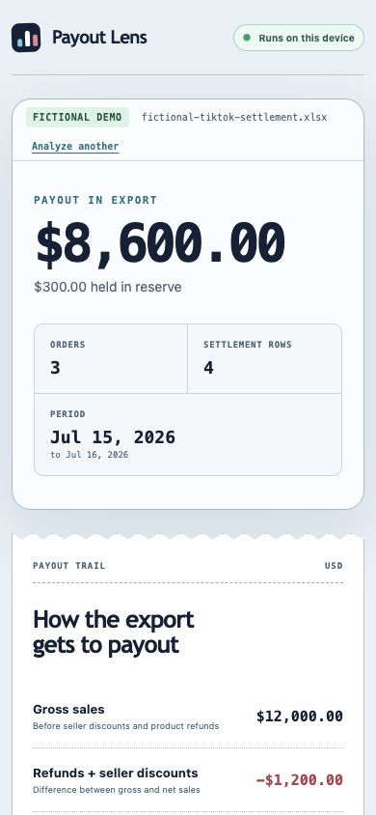 | 60-SECOND FLOW  - Hook: What happened to my payout?  - Proof: no plugin, login, or upload.  - Click the fictional demo.  - Pause on the large payout reveal.  - Scroll through the payout trail.  - Show deductions and Review Queue.  - End on the CSV downloads and bookmark CTA.
Public recording rule
Use fictional data only. Crop out browser tabs, local file paths, unrelated desktop content, and any real seller or customer information.

Privacy and product boundary
Payout Lens requires no plugin, installation, login, API key, server, analytics, or cloud upload. It explains signed amounts and arithmetic in the exported report. It does not inspect bank activity or include product costs, ad spend, or outside shipping costs.
Payout Lens is not affiliated with TikTok. Verify important totals in Seller Center. It is not accounting, tax, legal, or financial advice.

